**Assignment # 1**

1. URL link for GitHub for the code:

<https://github.com/abhishekpras/Assignment_1_Console>

1. Print prime numbers between two numbers (5 and 15)
2. Logic (including appropriate organization of logic into methods) and Handling all reasonable corner cases

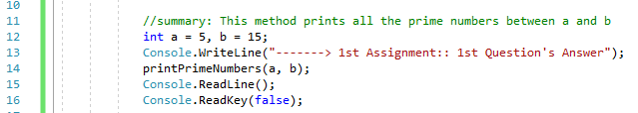

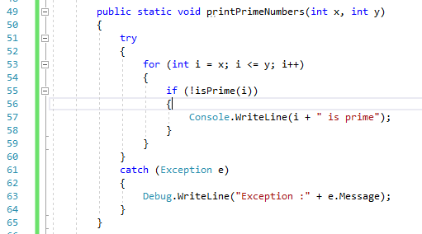

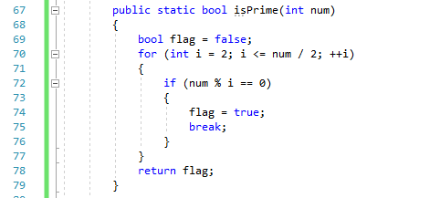

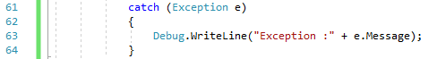

1. Descriptive comments explaining the logic to reviewer

A prime # is a positive integer which is divisible only by 1 and itself.

1. Self-reflection (learning, recommendations to improve for you, time taken)

This gives opportunity to work with variables and loops with Boolean condition. And using try and catch block.

1. Solution:

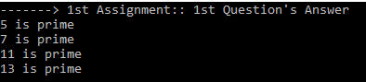

1. Compute the series 1 / 2 – 2!/ 3 + 3!/ 4 – 4!/ 5
2. Logic (including appropriate organization of logic into methods) and Handling all reasonable corner cases

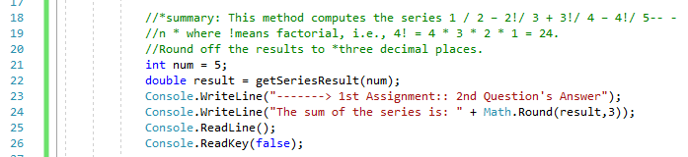

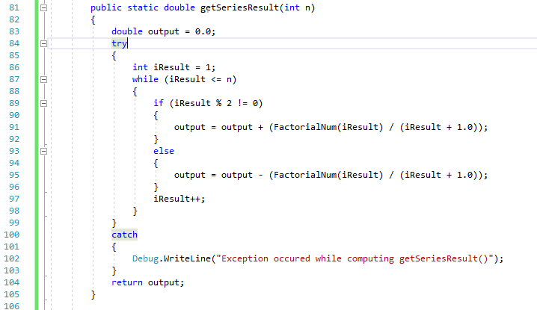

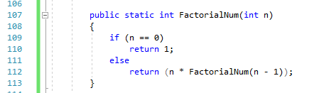

1. Descriptive comments explaining the logic to reviewer

To calculate the factorial, a recursion function is used.

1. Self-reflection (learning, recommendations to improve for you, time taken)

This gives opportunity to work with loops and recursion functions and using try and catch block.

1. Solution:



1. Print a triangle using * for five rows
2. Logic (including appropriate organization of logic into methods) and Handling all reasonable corner cases

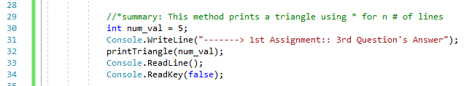

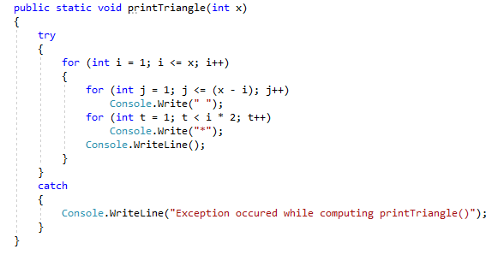

1. Descriptive comments explaining the logic to reviewer

The second loop within the loop is used to print the star. And the stars increases in each row as we go towards the base of the triangle. So the loop runs one more time for each iteration.

1. Self-reflection (learning, recommendations to improve for you, time taken)

This gives opportunity to work with multiple loops using try and catch block.

1. Solution:

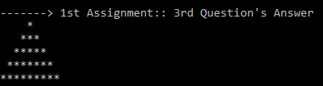

1. Compute the frequency of each element in the array
2. Logic (including appropriate organization of logic into methods) and Handling all reasonable corner cases

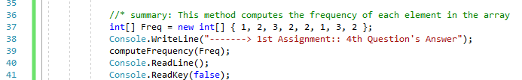

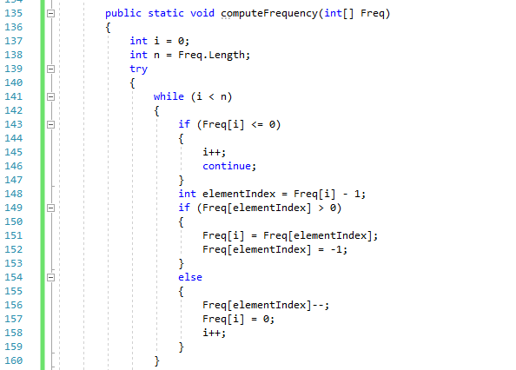

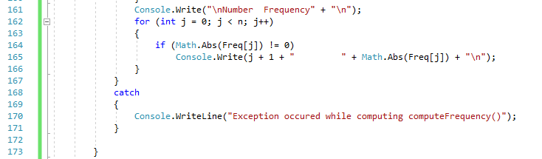

1. Descriptive comments explaining the logic to reviewer

For each element which match in array, the frequency (count) is increment by one.

1. Self-reflection (learning, recommendations to improve for you, time taken)

This gives opportunity to work with loops and matching using try and catch block.

1. Solution:

